**Release Notes**

for

New Golden City Builders

INSYS TIMEKEEPING SYSTEM

Prepared by: Aeroll C. Dela Cerna

Date of Issue: January 30, 2020

Version: 1.1.51.1

Status: Draft

Contents

**I.** **Document Control** 3

History 3

Related Documents 6

Authorised signature 11

**II.** **INTRODUCTIONS** 12

**III.** **New Features & Enhancement** 15

**IV.** **Fixed Issue** 25

**V.** **Known Issues** 52

# **Document Control**

## History

Below is listed the change history of this document.

|  |  |  |  |
| --- | --- | --- | --- |
| **Version** | **Date** | **Author** | **Changes** |
| **1.1.7.1** | 04/24/2018 | Hana B. Bakun | Fix undertime after coffee break or during coffee break. |
| **1.1.8.1** | 05/11/2018 | Hana B. Bakun | Add column on Employee Attendance Log File Module |
| **1.1.9.1** | 05/18/2018 | YokuPanuelos | Add restriction on Holiday and Sunday OT. |
| **1.1.10.1** | 05/23/2018 | Hana B, Bakun | Must allow multiple IP Address with different Project on Log Device Module. Fix DTR and DTR 1 Report. |
| **1.1.10.2** | 05/23/2018 | Hana B. Bakun | Added report function. |
| **1.1.10.3** | 05/29/2018 | Hana B. Bakun | Updated Report Function and Report File. |
| **1.1.11.1** | 05/25/2018 | Hana B. Bakun | Added new module under InSys Orbit > Timekeeping Items for re-checking/validation of data that does not have the capability to reprocess or recompute the Timekeeping. |
| **1.1.12.1** | 05/28/2018 | Yoku E. Panuelos | Added new policy and validation for filing of leave |
| **1.1.12.2** | 05/28/2018 | Yoku E. Panuelos | Added new policy and validation for filing of leave(recode) |
| **1.1.13.1** | 05/30/2018 | Yoku E. Panuelos | Fixed bug on missed log application procedure. |
| **1.1.14.1** | 06/01/2018 | Remil Riel | Fixed bug on date time format issue of windows. |
| **1.1.15.1** | 06/05/2018 | Hana B. Bakun | Update DTR and DTR1 Report. |
| **1.1.16.1** | 06/06/2018 | Hana B. Bakun | Required Fields: Division and Employee Classification on Employe Template File. |
| **1.1.17.1** | 06/11/2018 | Hana B. Bakun | Added Validation on ETF Module. |
| **1.1.18.1** | 06/11/2018 | Hana B. Bakun | Policy before and after Holiday and with leave. Leave can be with or without pay. |
| **1.1.18.2** | 06/19/2018 | Hana B. Bakun | Policy before and after Holiday and with leave. Leave can be with or without pay. |
| **1.1.18.3** | 06/27/2018 | Hana B. Bakun | Update Daily Employees Special Holiday Policy. |
| **1.1.19.1** | 06/14/2018 | Yoku E. Panuelos | Fixed bug on date time format issue of windows again. |
| **1.1.20.1** | 06/19/2018 | Yoku E. Panuelos | Fixed issue on search column filter |
| **1.1.21.1** | 07/03/2018 | Hana B. Bakun | Display log name on Employee Time Record and Update DTR and DTR1 Report. |
| **1.1.22.1** | 07/09/2018 | Bruce Joshua Neyra | Added Validation for Filing Maintenance |
| **1.1.23.1** | 07/12/2018 | Hana B. Bakun | Timekeeping two consecutive OT for Workers update. |
| **1.1.24.1** | 07/17/2018 | Bruce Joshua Neyra | Added Validation for different types of leave |
| **1.1.24.1** | 07/17/2018 | Bruce Joshua Neyra | Added Validation for different types of leave |
| **1.1.25.1** | 07/25/2018 | Hana Bakun | Update DTR Report |
| **1.1.26.1** | 09/14/2018 | Hana Bakun | Update Employee Classication |
| **1.1.27.1** | 09/19/2018 | Hana Bakun | Update two consecutive day OT for Workers. |
| **1.1.28.1** | 9/26/2018 | Geormin Guian Salanguit | Fixed Employee template file error on applying. |
| **1.1.29.1** | 9/27/2018 | Geormin Guian Salanguit | Removed validation when approving zero credit leaves. |
| **1.1.30.1** | 10/11/2018 | Geormin Guian Salanguit | Adjust the logs for OBStraightDuty. |
| **1.1.31.1** | 10/12/2018 | Geormin Guian Salanguit | Change of schedule for next day when straight duty. |
| **1.1.32.1** | 11/12/2018 | Geormin Guian Salanguit | DTR report loading optimization |
| **1.1.34.1** | 1/28/2019 | Geormin Guian Salanguit | Calendar logs arrangement and sick leave error message. |
| **1.1.35.1** | 02/12/2019 | El John D. Montealegre | Missed Log Error |
| **1.1.36.1** | 02/14/2019 | El John D. Montealegre | Overtime duplicate |
| **1.1.37.1** | 03/18/2019 | Joshua B. Cordova | Leave Filing Policy |
| **1.1.38.1** | 03/21/2019 | Joshua B. Cordova | Overtime Filing – EDS |
| **1.1.38.2** | 04/04/2019 | Joshua B. Cordova | Overtime Filing – EDS |
| **1.1.39.1** | 04/04/2019 | Joshua B. Cordova | The system must not include the holidays when filing of leave and must not tagged as with pay. |
| **1.1.40.1** | 04/11/2019 | Joshua B. Cordova | Government Table SSS,PHIC,HDMC |
| **1.1.41.1** | 04/30/2019 | Joshua B. Cordova | Payroll item setup template |
| **1.1.42.1** | 05/03/2019 | Joshua B. Cordova | Adding EndDate in loan module and loan file |
| **1.1.43.1** | 07/02/2019 | Joshua B. Cordova | Calendar issue for May And June |
| **1.1.44.1** | 07/02/2019 | Joshua B. Cordova | Withholding tax |
| **1.1.45.1** | 07/03/2019 | Joshua B. Cordova | Holiday |
| **1.1.46.1** | 07/23/2019 | Joshua B. Cordova | * Reflect bio device source Name * ETF uploading * Affecting absences at payroll item setup option * OB Reason * Calendar Logs * OB with coffee Break |
| **1.1.47.1** | 08/02/2019 | Joshua B. Cordova | * OT Filing on the same workdate * New Column on Every filling type * Time and Attendance Processing |
| **1.1.48.1** | 09/11/2019 | Joshua B. Cordova | * Error in employee time record * Holidays in IONS Calendar |
| **1.1.49.1** | 09/20/2019 | Joshua B. Cordova | * Straight Duty overtime |
| **1.1.50.1** | 01/29/2020 | Christopher G. Macapagal | * *Tk Optimization* |
| **1.1.51.1** | 01/30/2020 | Aeroll C. Dela Cerna | *Revisions of the following report: (Batch 2)*   * Payroll Sheet (NGCB) fix Computation of column (N) and (AI) * SSS Loan – Added record number * Summary Attendance – Fix computation * HDMF Loan * Man power costing * SSS Report * HDMF Report * PHIC Report * Payroll sheet ngcb subcon |

## Related Documents

|  |  |  |  |  |
| --- | --- | --- | --- | --- |
|  | **Document** | **Author** | **Issue** | **From date** |
| **1.1.7.1** | Redmine #628 | Gian Carlo Doco | Undertime Bug | 04/16/2018 |
| **1.1.8.1** | Redmine #1091  Change Request | Gian Carlo Doco | Log Device – Feature | 05/11/2018 |
| **1.1.9.1** | Redmine #1019 | Gian Carlo Doco | Overtime Web IONS Policy | 05/10/2018 |
| **1.1.10.1**  **1.1.10.2**  **1.1.10.3** | Redmine #1159 | Gian Carlo Doco | Log Device Module | 05/21/2018 |
|  | Redmine #1178 | Gian Carlo Doco | DTR Report | 05/22/2018 |
| **1.1.11.1** | Redmine #1249  Change Request | Gian Carlo Doco | IsForChecking | 05/24/2018 |
| **1.1.12.2** | Redmine #1020  Change Request | Gian Carlo Doco | Leave Filing Policy | 05/10/2018 |
| **1.1.13.1** | Redmine #1328 | Gian Carlo Doco | Missed Log Bug | 05/29/2018 |
| **1.1.14.1** | Redmine #1341 | Gian Carlo Doco | Filing of Leave Application | 05/30/2018 |
| **1.1.15.1** | Redmine #1391 | Gian Carlo Doco | DTR Reports | 06/05/2018 |
| **1.1.16.1** | Redmine #1403 | Gian Carlo Doco | ETF – Required Column | 06/04/2018 |
| **1.1.17.1** | Redmine #1531 | Gian Carlo Doco | NGCB – ETF | 06/10/2018 |
| **1.1.18.1**  **1.1.18.2**  **1.1.18.3** | Redmine #1486 | Gian Carlo Doco | Leave B&A Policy | 06/07/2018 |
| **1.1.19.1** | Redmine #1341 | Gian Carlo Doco | Filing of Leave Application | 06/14/2018 |
| **1.1.20.1** | Redmine#1601 | Gian Carlo Doco | Search - IONS | 06/18/2018 |
| **1.1.21.1** | Redmine #1677  Redmine #1678 | Gian Carlo Doco | Employee Time Record.  DTR Report | 06/22/2018  06/24/2018 |
| **1.1.22.1** | Redmine #1769  Redmine #1838 | Gian Carlo Doco | Time Limit and Allowed Current Work Date Bugs on IONS Filing Maintenance  Overtime File | 07/09/2018  07/08/2018 |
| **1.1.23.1** | Redmine #1906 | Gian Carlo Doco | Timekeeping | 07/11/2018 |
| **1.1.24.1** | Redmine #1769 | Gian Carlo Doco | Time Limit and Allowed Current Work Date Bugs on IONS Filing Maintenance | 07/09/2018 |
| **1.1.24.1** | Redmine #1769 | Gian Carlo Doco | Time Limit and Allowed Current Work Date Bugs on IONS Filing Maintenance | 07/09/2018 |
| **1.1.25.1** | Redmine #1985 | Gian Carlo Doco | Report – DTR | 07/20/2018 |
| **1.1.26.1** | Redmine #2490  Change Request | Gian Carlo Doco | Timekeeping –Overtime | 09/05/2018 |
| **1.1.27.1** | Redmine #2490 | Gian Carlo Doco | Timekeeping – Overtime | 09/05/2018 |
| **1.1.28.1** | Redmine #2853 | Gian Carlo Doco | Error upon applying ETF. | 9/25/2018 |
| **1.1.29.1** | Redmine #2902 | Gian Carlo Doco | All the Leave Item must not require Leave Credits | 9/27/2018 |
| **1.1.30.1** | Redmine #3044 | Gian Carlo Doco | OB-Straight duty cannot be computed | 10/09/2018 |
| **1.1.31.1** | Redmine #3078 | Gian Carlo Doco | Change of schedule not automatically executed when straight duty. | 10/12/2018 |
| **1.1.32.1** | Redmine #3301 | Gian Carlo Doco | Payslip report access | 11/06/2018 |
| **1.1.34.1** | Redmine#3972,3974 | Gian Carlo Doco | Calendar logs and Sick leave filing error. | 1/10/2019 |
| **1.1.35.1** | Redmine#4329 | Gian Carlo Doco | Missed Log Error | 02/08/2019 |
| **1.1.36.1** | Redmine#4360 | Gian Carlo Doco | Overtime Duplicate | 02/14/2019 |
| **1.1.37.1** | Redmine#4522 | Gian Carlo Doco | Leave Filing Policy | 03/08/2019 |
| **1.1.38.1** | Redmine#4496 | Gian Carlo Doco | Overitime Filing – EDS | 03/05/2019 |
| **1.1.38.2** | Redmine#4496 | Gian Carlo Doco | Overitime Filing – EDS | 04/04/2019 |
| **1.1.39.1** | Redmine#4781 | Gian Carlo Doco | Leave During Holiday | 04/03/2019 |
| **1.1.40.1** | Redmine #4635 | Gian Carlo Doco | Government tables | 04/11/2019 |
| **1.1.41.1** | Redmine #4988 | Gian Carlo Doco | Payroll Item setup template | 04/29/2019 |
| **1.1.42.1** | Redmine #4637 | Gian Carlo Doco | Loan/Loan File | 05/03/2019 |
| **1.1.43.1** | Redmine #5437 | Gian Carlo Doco | Calendar issue for May and June | 06/27/2019 |
| **1.1.44.1** | Redmine #5440 | Gian Carlo Doco | WHtax | 06/27/2019 |
| **1.1.45.1** | Redmine #5453 | Gian Carlo Doco | Holiday | 07/12/2019 |
| **1.1.46.1** | Redmine #5567 | Carlo Abendanio | Reflect Bio Device Source Name | 08/22/2019 |
| Redmine #5566 | ETF Uploading |
| Redmine #5449 | Affecting absences at payroll item setup option |
| Redmine #5763 | Ob with coffee break |
| Redmine #3972 | Calendar Logs |
| Redmine #5769 | OB Reason |
| **1.1.47.1** | Redmine #4639  Redmine #5781  Redmine #5438 | Carlo Abendanio | * OT filing on the same workdate * New column on every filing * Time and attendance processing | 03/21/2019 |
| **1.1.48.1** | Redmine #5812  Redmine #5814 | Carlo Abendanio | * Error In Employee Time Record * Holidays in Ions Calendar | 8/27/2019 |
| **1.1.49.1** | Redmine #6061 | Carlo Abendanio | * Straight Duty for workers | 09/20/2019 |
| **1.1.50.1** | Redmine #6095 | Austin Viterbo | * Timekeeping Optimization | 01/29/2020 |
| **1.1.51.1** | Redmine #4642  Redmine #4643  Redmine #4644  Redmine #4645  Redmine #4646  Redmine #4647 | Austin Viterbo | * Payroll sheet (Sub-con) * Payroll sheet (NGCB) * SSS, PHIC, HDMF Report * Manpower Costing Report * HDMF & SSS Loan * Summary Attendance Report | 01/30/2020 |

## Authorised signature

|  |  |  |  |
| --- | --- | --- | --- |
| **Name** | **Title** | **Signature** | **Date of Signature** |
|  |  |  |  |
|  |  |  |  |
|  |  |  |  |

# **INTRODUCTIONS**

**1.1.7.1**

* The purpose of this release is to fix the bugs that have been seen during the checking for Undertime.

## **1.1.8.1**

* The purpose of this release is to add a “Log Device” Column on Employee Attendance Log File Module to populate the “Souce” column when the Attlog(.dat) File is uploaded.

**1.1.9.1**

* The purpose of this release is to fix the issue on Overtime Web IONS Policy. In case employee will take the OT for holiday and Sunday Duty. He/She will need to have an advance filing date between 3-7 days before the work date.

**1.1.10.1**

**1.1.10.2**

**1.1.10.3**

* The purpose of this release is to update restriction on the Log Device Module it must allow to add another log device with the same IP address but different Project and fix DTR and DTR 1 report.

**1.1.11.1**

* The purpose of this release is to add a Module that will display data that needs to be re-check or revalidate and does not have the capability to recompute or reprocess the Timekeeping.

**1.1.12.1**

**1.1.12.2**

* The purpose of this release is to add a new policy which will take to those whom may file leave earlier in accordance with the new filing of leave policy.

**1.1.13.1**

* The purpose of this release is to fixed the bug on missed log application process.

**1.1.14.1**

* The purpose of this release is to fixed the bug of date time format caused by windows updates.

**1.1.15.1**

* The purpose of this release is to remove extra rows on exported Excel file from DTR 1 Reports.

**1.1.16.1**

* The purpose of this release is to update required fields on the Employee Template File.

**1.1.17.1**

* The purpose of this release is to add new validation on the Employee Template File Module.

**1.1.18.1**

**1.1.18.2**

**1.1.18.3**

* The purpose of this release is to update the Holiday Policy.

**1.1.19.1**

* Fixed the date time format bug of windows update causes an error to file an application for leave of employees.

**1.1.20.1**

* Fixed error (404 error) issue on search column filter.

**1.1.21.1**

* The purpose of this release is to display the Log Device Name and update the DTR and DTR1 Report that does not display some filings.

**1.1.22.1**

* Added Validation for Filing Maintenance
* Fixed the error in Overtime

**1.1.23.1**

* The purpose of this update is to fix the comment for Workers with two consecutive overtime.

**1.1.24.1**

* Added Validation for different types of Leave

**1.1.24.2**

* Added Validation for different types of Leave
* Fixed Script Error

**1.1.25.1**

* The purpose of this release is to remove the logs that are not from the Mother Bio on DTR Reports.

**1.1.26.1**

* The purpose of this release is to update and add a new employee classification.

**1.1.27.1**

* The purpose of this release is to update the computation for two consecutive day OT for Workers.

**1.1.28.1**

* Fix Employee template file error on applying.

**1.1.29.1**

* Remove the validation of leave approval for zero leave credit items.

**1.1.30.1**

* Adjust the logs for Ob-Straight duty scenario.

**1.1.31.1**

* Fix the employee change of schedule when straight duty.

**1.1.32.1**

* Optimize the DTR report module when loading.

**1.1.34.1**

* Fix the arrangement of logs on calendar and fix the popup error message upon applying of sick leave.

**1.1.35.1**

* Fix missed log upon approval for log type.

**1.1.36.1**

* Fix overtime duplicate.

**1.1.37.1**

* Update Scripts – Change Request

**1.1.38.1**

* Update Scripts in arrange logs

**1.1.38.2**

* Sub query error

**1.1.39.1**

* the system must not include the holidays when filing of leave and must not tagged as with pay

**1.1.40.1**

Government tables updates

**1.1.41.1**

* fix batch uploading of payroll item setup

**1.1.42.1**

* Adding end date on loan file and loan module in payroll module

**1.1.43.1**

* Calendar issue

**1.1.44.1**

* With Holding Tax

**1.1.45.1**

* Holiday

**1.1.46.1**

* Reflect Bio Device Source Name
* ETF Uploading
* Affecting absences at payroll item setup option
* OB with break
* OB Reason
* Calendar Logs

**1.1.47.1**

* OT Filing on the same work date
* New Column of Every filing Type
* Time and Attendance Processing

**1.1.48.1**

* Error in employee time record to load in other company
* Holidays in IONS Calendar

**1.1.49.1**

* Straight duty ot for workers

**1.1.50.1**

* Timekeeping Optimization

**1.1.51.1**

* Payroll Sheet (Sub-con) reports
* Payroll Sheet (NGCB) reports
* SSS,PHIC and HDMF reports
* Summary Attendance Reports
* Man Power Costing Report
* SSS and HDMF Loan Report

**New Features & Enhancement**

**1.1.7.1**

|  |  |
| --- | --- |
| **Name** | **Description** |
| Undertime Bug | Fix undertime after coffee break or during coffee break. |

**1.1.8.1**

|  |  |
| --- | --- |
| **Name** | **Description** |
| Log Device | Add column on Employee Attendance Log File Module as per request. |

**1.1.9.1**

|  |  |
| --- | --- |
| **Name** | **Description** |
| Overtime Web IONS Policy | Add restriction on OT For Holiday and Sunday Duty. |

**1.1.10.1**

**1.1.10.2**

**1.1.10.3**

|  |  |
| --- | --- |
| **Name** | **Description** |
| Log Device Module | allow to add another log device with the same IP address but different Project |
| DTR Report | Remove duplicated OB and Additional Row Space once exported to Excel. |

**1.1.11.1**

|  |  |
| --- | --- |
| **Name** | **Description** |
| Employee Attendance Log View | Add Module under InSys Orbit > Timekeeping Items |

**1.1.12.1**

**1.1.12.2**

|  |  |
| --- | --- |
| **Name** | **Description** |
| Leave Web IONS Policy | New policy for filing of leave Orbit > Timekeeping Items |

**1.1.13.1**

|  |  |
| --- | --- |
| **Name** | **Description** |
| Missed Log Bug | Fixed missed log bug on application process > Timekeeping Items |

**1.1.14.1**

|  |  |
| --- | --- |
| **Name** | **Description** |
| Filing of Leave Application error | Fixed leave application error caused by windows updates > Timekeeping items |

**1.1.15.1**

|  |  |
| --- | --- |
| **Name** | **Description** |
| DTR Reports | Remove extra rows on exported Excel file from DTR 1 Report. |

**1.1.16.1**

|  |  |
| --- | --- |
| **Name** | **Description** |
| Employee Template File | Added “Valid” Column on Employee Template File to identify if any record is invalid. |

**1.1.17.1**

|  |  |
| --- | --- |
| **Name** | **Description** |
| Employee Template File | Added validation on Employee Template File Module. |

**1.1.18.1**

**1.1.18.2**

**1.1.18.3**

|  |  |
| --- | --- |
| **Name** | **Description** |
| Holiday Policy | Employee must be present before and after holiday. If they have an approved leave, with or without pay, holiday will still be paid. |

**1.1.19.1**

|  |  |
| --- | --- |
| **Name** | **Description** |
| Filing of Leave Application error | Fixed leave application error caused by windows updates > Timekeeping items |

**1.1.20.1**

|  |  |
| --- | --- |
| **Name** | **Description** |
| Fixed error on search | Fixed error (404 error) issue on search column filter> Timekeeping items |

**1.1.21.1**

|  |  |
| --- | --- |
| **Name** | **Description** |
| DTR Report | Display missing approved filing on the DTR and DTR1 Report. |
| Employee Time Record | Display Log Device Namesregardless if the logs are from other Biometric. |

**1.1.22.1**

|  |  |
| --- | --- |
| **Name** | **Description** |
| Filing Maintenance | Added Time Limit Validations for Filing Maintenance |
| Overtime File | Fixed the error in Overtime, regarding new records |

**1.1.23.1**

|  |  |
| --- | --- |
| **Name** | **Description** |
| Timekeeping | Fix comment on workerswith two consecutive overtime. |

**1.1.24.1**

|  |  |
| --- | --- |
| **Name** | **Description** |
| Filing Maintenance | Added Validations for Leave Types in Filing Maintenance |

**1.1.24.2**

|  |  |
| --- | --- |
| **Name** | **Description** |
| Filing Maintenance | Added Validations for Leave Types in Filing Maintenance |

**1.1.25.1**

|  |  |
| --- | --- |
| **Name** | **Description** |
| DTR Report  DTR1 Report | Update reports. |

**1.1.26.1**

|  |  |
| --- | --- |
| **Name** | **Description** |
| Time and Attendance Processing | Processing of each Employee Classifcation. |
| Employee Classification | Add and update Classification. |
|  |  |

**1.1.27.1**

|  |  |
| --- | --- |
| **Name** | **Description** |
| Time and Attendance Processing | Computation for two consecutive day Overtime for Workers – Employee Classification. |

**1.1.28.1**

|  |  |
| --- | --- |
| **Name** | **Description** |
| Employee Template File | Applying Employee Template File error fixed. |

**1.1.29.1**

|  |  |
| --- | --- |
| **Name** | **Description** |
| Leave approval | No validation for leave approval |

**1.1.30.1**

|  |  |
| --- | --- |
| **Name** | **Description** |
| OB-Straight duty | OB to Straight duty supported. |

**1.1.31.1**

|  |  |
| --- | --- |
| **Name** | **Description** |
| Change of schedule | Automatically change of schedule when straight duty. |

**1.1.32.1**

|  |  |
| --- | --- |
| **Name** | **Description** |
| DTR report | DTR report optimized. |

**1.1.34.1**

|  |  |
| --- | --- |
| **Name** | **Description** |
| Sick Leave application | Fixed error upon posting. |
| Calendar logs | Rearrange logs. |

**1.1.35.1**

|  |  |
| --- | --- |
| **Name** | **Description** |
| Missed Log | Log type upon approval in Missed Log. |

**1.1.36.1**

|  |  |
| --- | --- |
| **Name** | **Description** |
| Overtime duplicate | Validate filed OT if have duplicate |

**1.1.37.1**

|  |  |
| --- | --- |
| **Name** | **Description** |
| Leave Filing Policy | Updated script for the version of 1.1.12.2 |

**1.1.38.1**

|  |  |
| --- | --- |
| **Name** | **Description** |
| Overtime filing – EDS | Update script in arrange logs |

**1.1.38.2**

|  |  |
| --- | --- |
| **Name** | **Description** |
| Overtime filing – EDS | Modify query procedure in arrange logs |

**1.1.39.1**

|  |  |
| --- | --- |
| **Name** | **Description** |
| Leave during Holiday | the system must not include the holidays when filing of leave and must not tagged as with pay |

**1.1.40.1**

|  |  |
| --- | --- |
| **Name** | **Description** |
| Government Tables | Update PHIC Table, SSS table and Income Tax table based on mandatory Government tables |

**1.1.41.1**

|  |  |
| --- | --- |
| **Name** | **Description** |
| Payroll Item setup Template | Batct uploading of payroll item setup  General rule: the payroll item code, set option ,amount, and periods can be overwrite, once the user re- import the same payroll item |

**1.1.42.1**

|  |  |
| --- | --- |
| **Name** | **Description** |
| Loan / Loan file | Add end Date at loan Module and loan file template |

**1.1.43.1**

|  |  |
| --- | --- |
| **Name** | **Description** |
| 1. Calendar Issue for May and June | Some of the employee cannot see their logs and other approved application in month of May, but they can view their and approved applications for the month. |
|  | |
| **1.1.44.1** | |
| **Name** | **Description** |
| 1. With Holding tax | Some employee have a lower minimum wage earner has computed a new table |
| **1.1.45.1** | |
| **Name** | **Description** |
| 1. Holiday | Shall Not paid for those employee who has not attendance in holiday |
| **1.1.46.1** | |
| **Name** | **Description** |
| 1. Reflect Bio Device Source Name 2. ETF Uploading 3. Affecting absences at payroll item setup option 4. OB reason 5. Calendar Logs 6. OB with Coffee Break | * If employee did not logged in his assigned biometric device, the source name of the other device should still reflect in system. * Error in uploading of ETF in employee template module * The employee should not get paid if has no attendance during legal holiday and special holiday * OB reason to display in Detail * Arrangement of logs from calendar * The system skips the coffee break out log in computing log in, counts OB in(OB end time) instead |
| **1.1.47.1** | |
| **Name** | **Description** |
| 1. OT filing on the same work date 2. New Column 3. Time and Attendance Processing | Restriction to post OT filing on the same workdare before 12 nn.    New Column for approver and approvers comment in time keeping module    Optimizing Time keeping computation |
| **1.1.48.1** | |
| 1. Error in employee Time record 2. Holidays in IONS Calendar | * Fix bug error loading of module * Holiday from another area should not reflect in calendar |
| **1.1.49.1** | |
| 1. Straight duty ot for workers | * Fix bug for ot filing on straight duty |
| **1.1.50.1** |  |
| **Name** | **Description** |
| 1. Timekeeping | Timekeeping Optimization |
| **1.1.51.1** |  |
| 1. Payroll sheet (Sub-con) 2. Payroll sheet (NGCB) 3. SSS, PHIC, HDMF Report 4. Manpower Costing Report 5. HDMF & SSS Loan 6. Summary Attendance Report | Feature reports for payroll process (Batch 02) |

# **Fixed Issue**

**1.1.7.1**

* Undertime Bug

Once the employee TIME OUT is less than equal to 4:30pm the employee will have 120 UT

Once the employee TIME OUT is greater than equal to 4:31pm the employee will have 59 UT

Schedule: 8:30am-5:30pm

8am IN

12pm BO

1pm BI

3:30pm BO

3:45pm BI

4:30 OUT

Expected Output: REG 7 UT 60

Insys Output: REG 6 UT 120

*Incorrect Output:

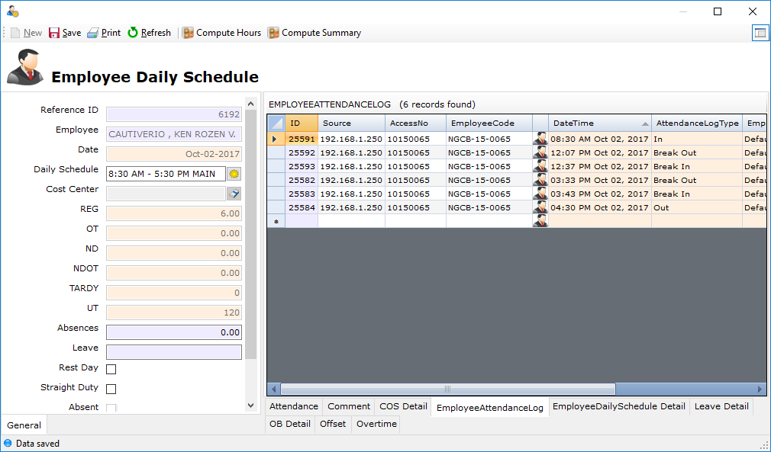

*Correct Output:

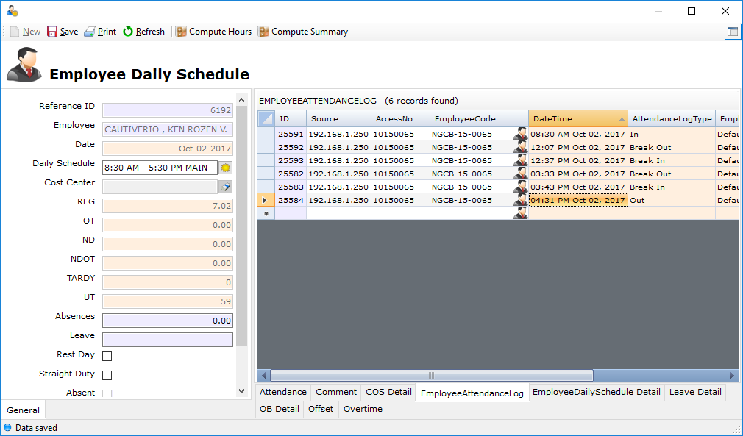

**1.1.8.1**

* Log Device – Feature

Add another Source field/column on Employee Attendance Log File to populate the Source/IP Address when the AttLog(.dat File) that came from the Biometric Device was import.

**1.1.9.1**

* Overtime Web IONS Policy

OT for Holiday and Sunday Duty

⎫ Minimum of seven (7) days before its effectivity  
⎫ Maximum of three (3) days on or before 12nn before its effectivity

NOTE: This is a different set-up for the REGULAR days, and this set-up is also included on the BFRD.

You may see the attached BFRD on FTP, for your reference.

**1.1.10.1**

**1.1.10.2**

**1.1.10.3**

* Log Device Module

Log Device module must set a different project on the same IP Address.

NGCB Site(Company) IP Address - 192.168.1.158  
Workers(Company) IP Address - 192.168.1.158

Please see the attached photo, for your reference.

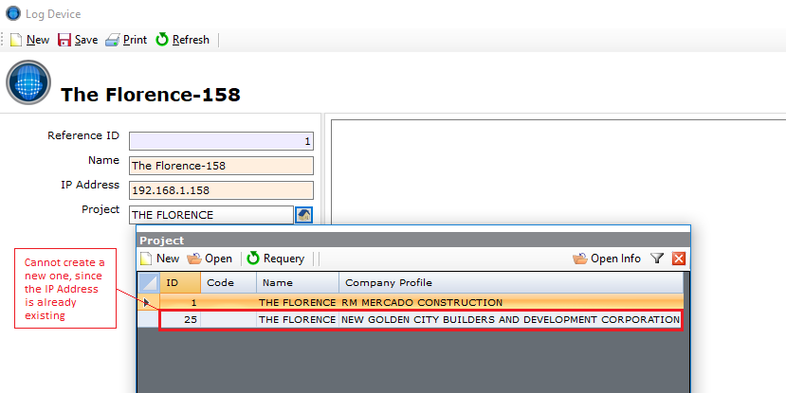

* DTR Report

Additional Row Space   
Duplicate of OB Application reflected on report

You may see the attached report file.

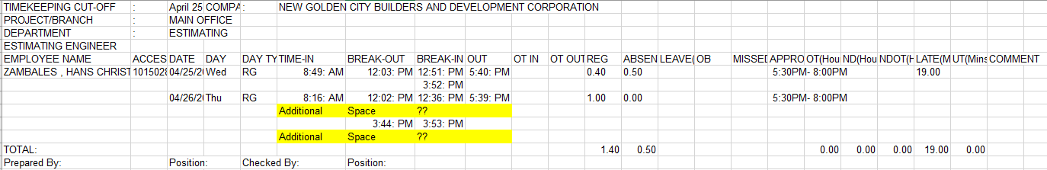

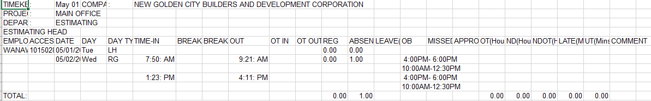

**1.1.11.1**

* IsForChecking

Additional module at Insys Orbit > Timekeeping Items and it will be name as “Employee Attendance Log View”.

The purpose of this is that, it can be sort the "IsForChecking" column by the user, to identify which of the employee is for re-checking/re-validation of its Timekeeping.

*NOTE: The new module does not have the capability to compute the Timekeeping Record nor Edit of all employee records, this is to avoid the conflicts on our TK Process.   
*NOTE: This report can be printed also.

You may see the signed Change Request on FTP Server.

**1.1.12.1**

**1.1.12.2**

* New Leave Policy with certain validations

Any types of Leave must have the same policy of this:

For 1 day LOA must be filed 1 day prior to its effectivity (CAN BE SET ON IONS FILING MAINTENANCE) For 2-7 consecutive days; LOA form must be filed 3 Days prior to its effectivity (VALIDATION UPON POSTING on IONS Web) For 8 days & up; LOA form must be filed 30 Days prior to its effectivity (VALIDATION UPON POSTING on IONS Web**)**

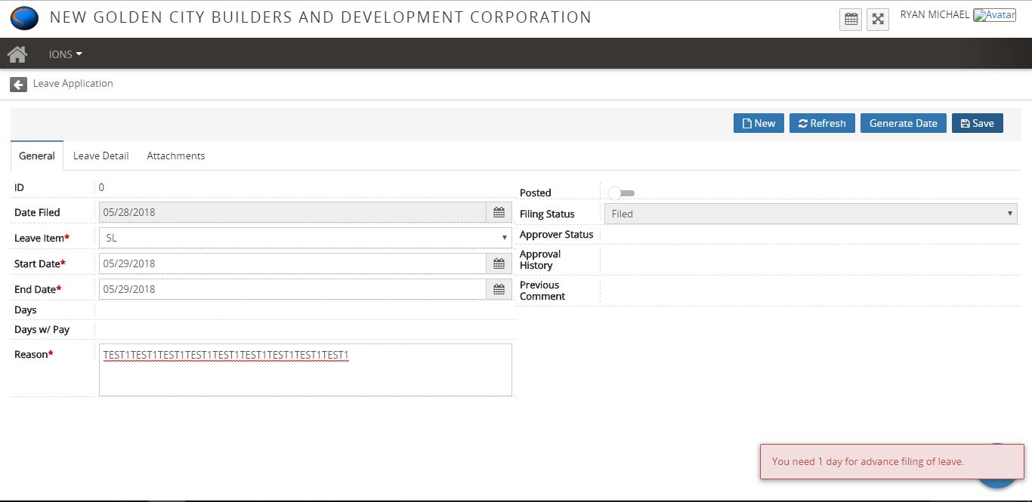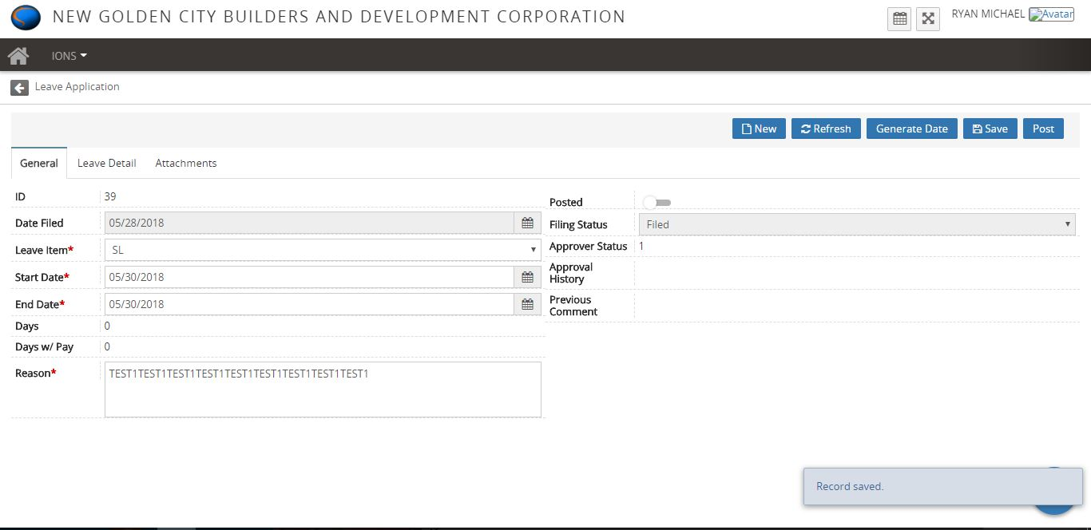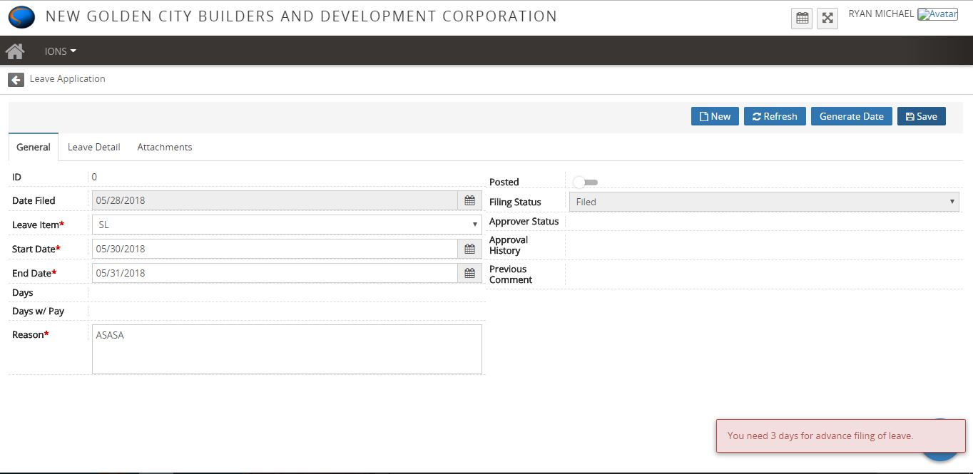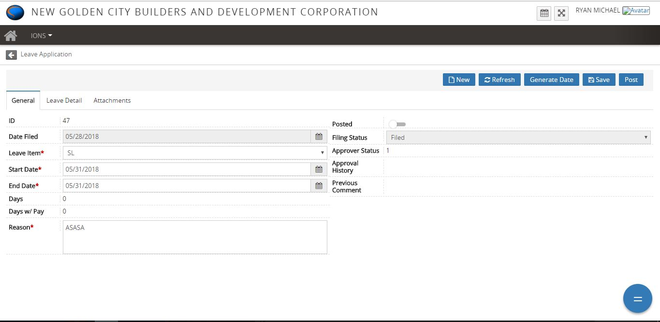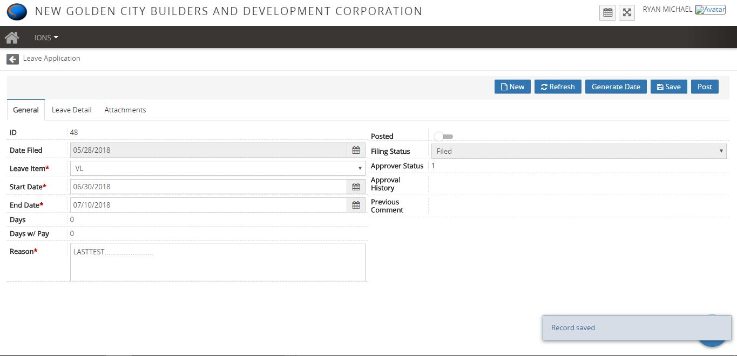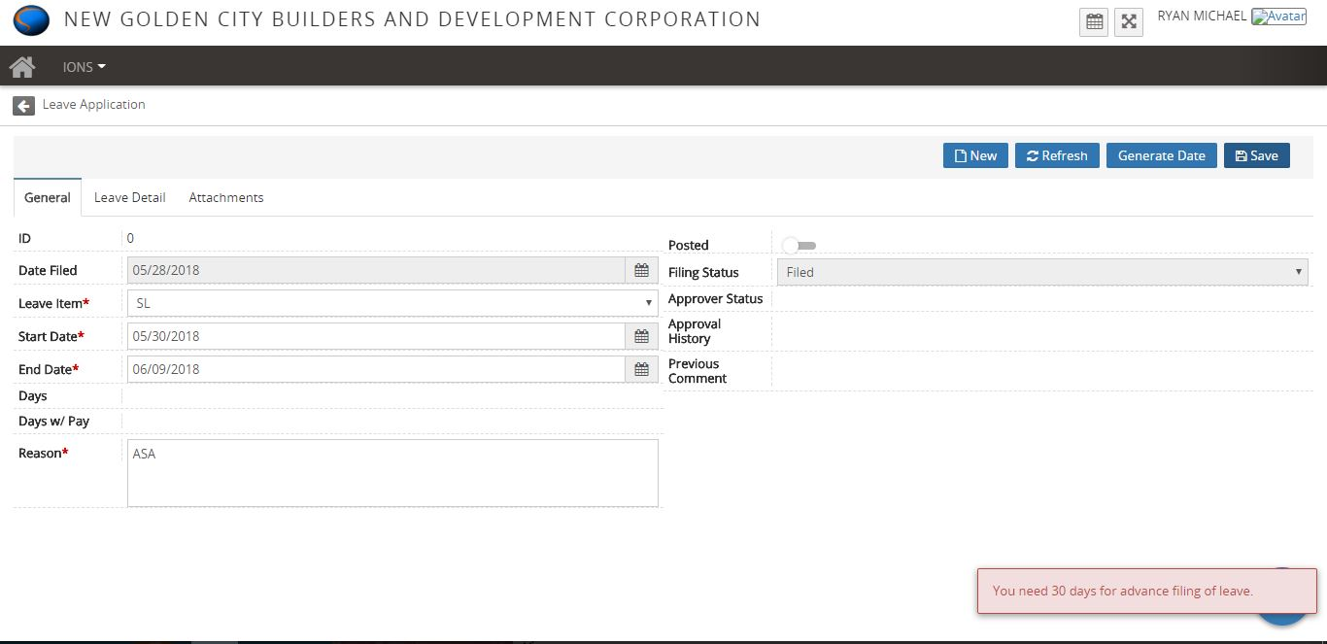

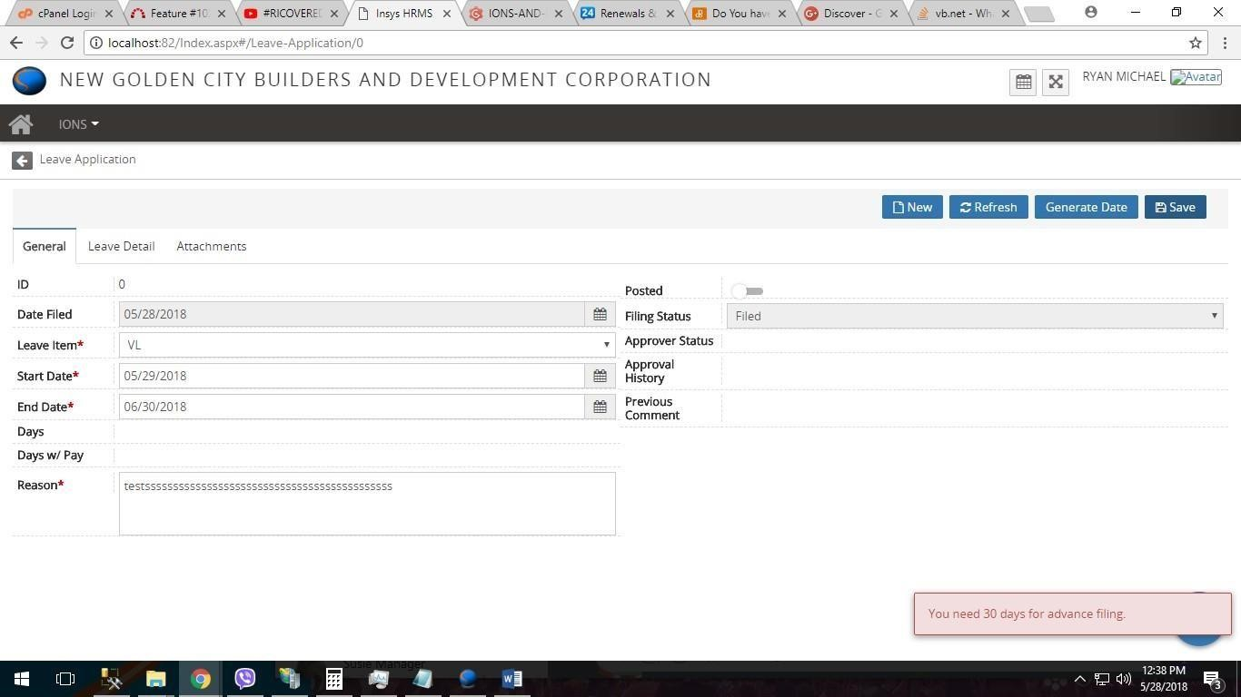

**1.1.13.1**

* Fixed bug on missed log application procedure

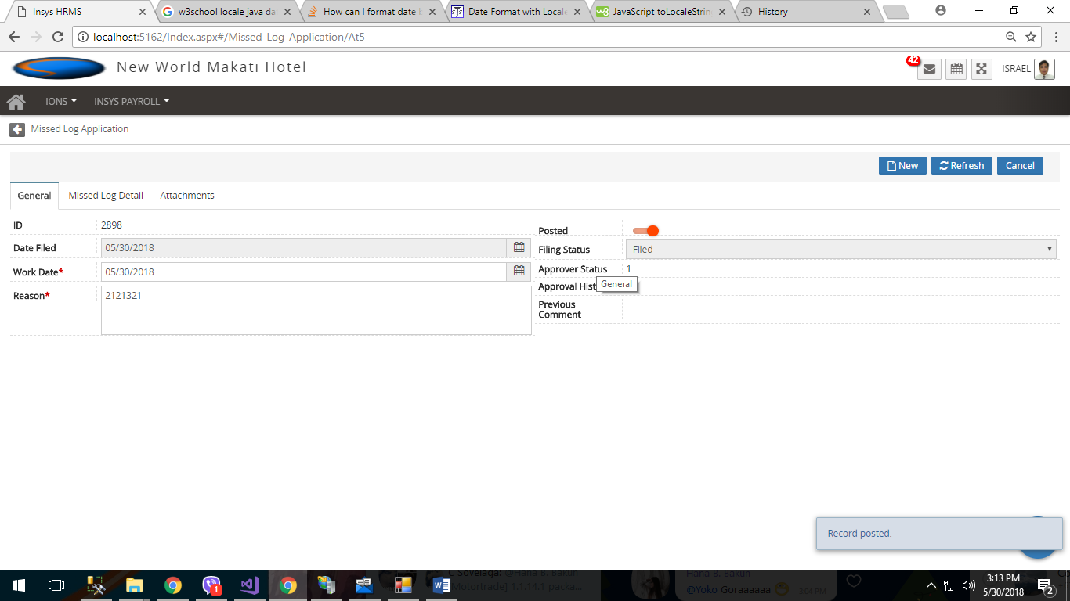

**1.1.14.1**

* Fixed the date time format bug of windows update causes an error to file an application for leave of employees.

**1.1.15.1**

* There's an Additional Row on DTR

Please see the attached photo, for your reference.

Sample Scenario  
Cruz, Ryan - April 26

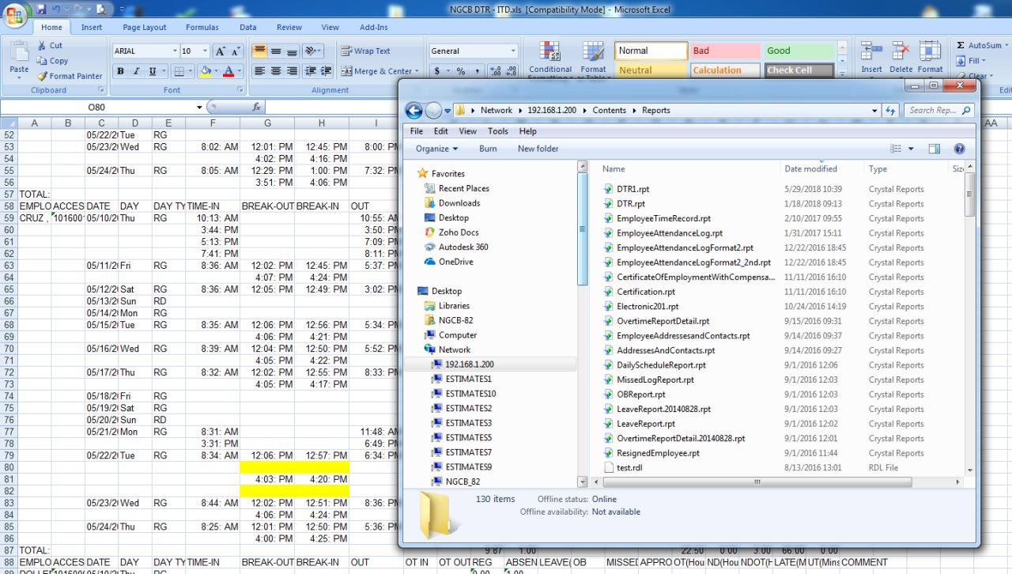

**1.1.16.1**

* Both Division and EmployeeClassification column must be a required field to avoid no computation of timekeeping.

**1.1.17.1**

* Off-site support importing of ETF

**ETF for the workers (Payroll Scheme - Daily)

**1.1.18.1**

**1.1.18.2**

**1.1.18.3**

* If the employee approved leave was either, with or without pay on before or after the holiday, the system must still pay the holiday of the employee.

You may see the attached scenario here and FTP Server, also the signed Change Request.

**1.1.19.1**

* Fixed the date time format bug of windows update causes an error to file an application for leave of employees.

**1.1.20.1**

* Fixed error (404 error) issue on search column filter.

**1.1.21.1**

* Employee Time Record

Logs from other Biometric(other project) must also be seen at Log Device Name in Employee Time Record.

Please see the attached photo, for your reference.

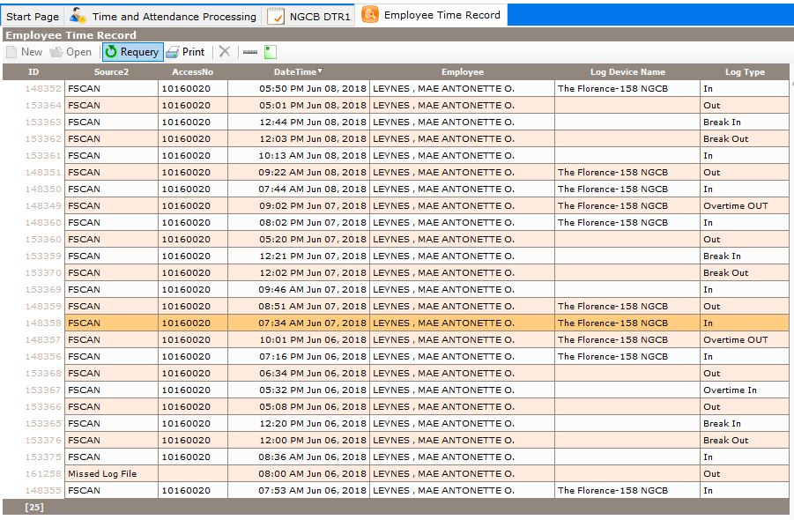

* DTR Report

Approved OB and OT does not reflect on the DTR even if the system computes correctly.

Please see the attached DTR sample, for your reference.

#you may get a copy of DB at FTP server

**1.1.22.1**

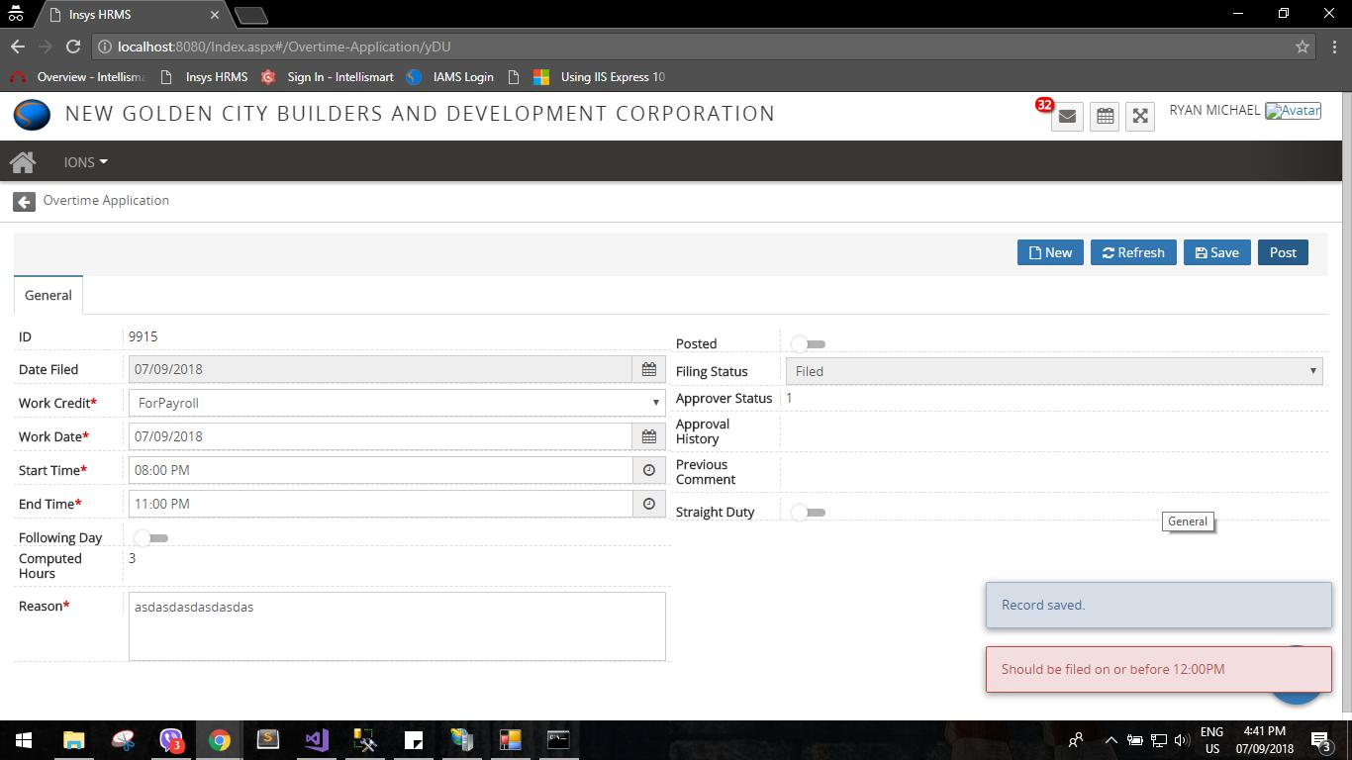

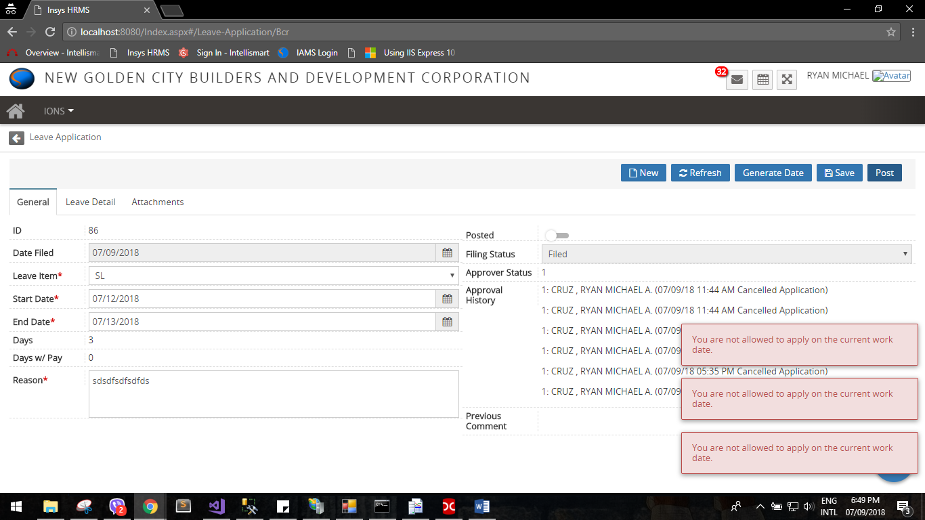

* Added Validation regarding Time Limit and Allowed Current Date
* Fixed Overtime Module

**1.1.23.1**

* Timekeeping

1. Wrong computation of OT   
2. Two consecutive days OT

please see the attached photo, for your reference.

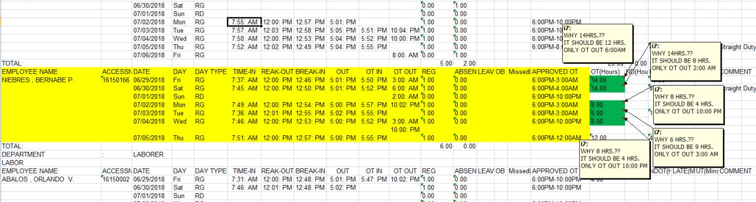

**1.1.24.1**





* Added Validation for Leave Types regarding Time Limit and Allowed Current Date

**1.1.24.2**





* Added Validation for Leave Types regarding Time Limit and Allowed Current Date

**1.1.25.1**

* It reflects the logs from another Biometric Device.

Please refer on the Log OUT. For your checking pls

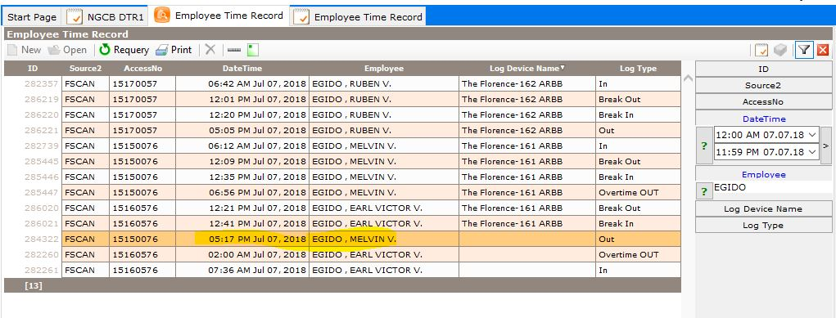

**1.1.26.1**

* Timekeeping – Overtime

Help us for a work-around on Overtime if the policy of monitoring on OT In and OT Out was implemented.

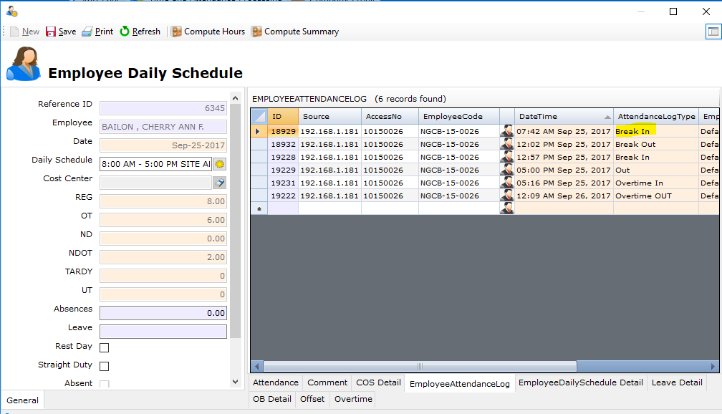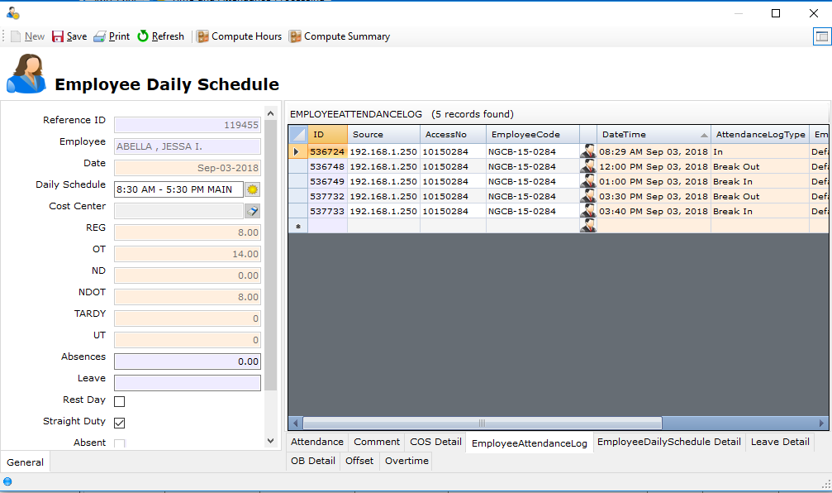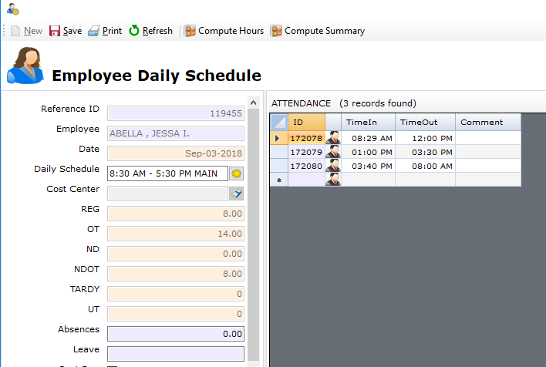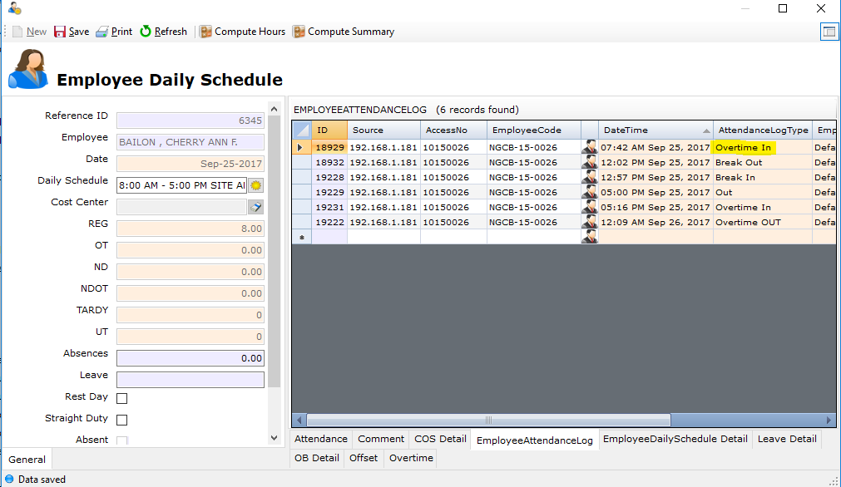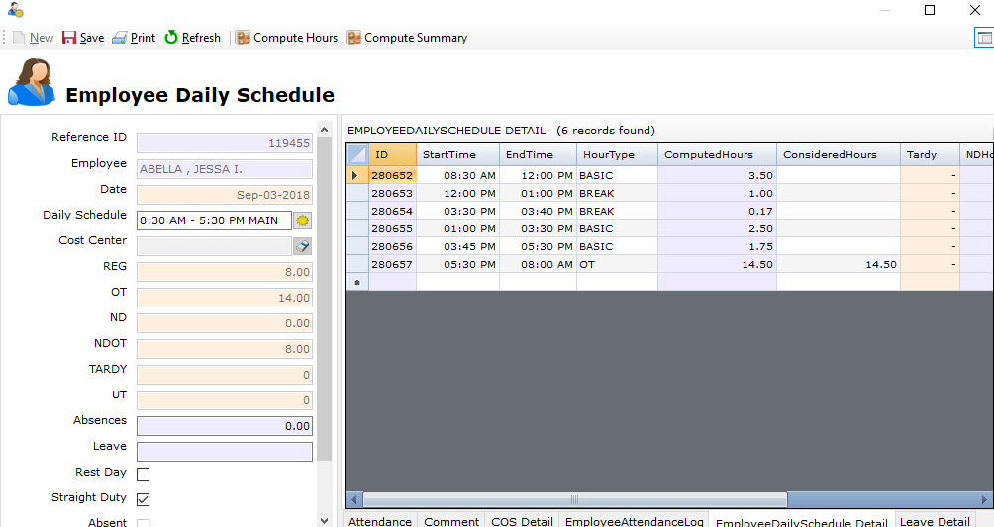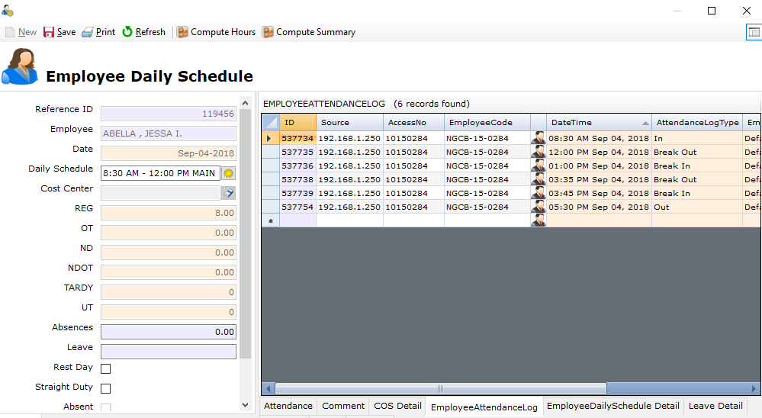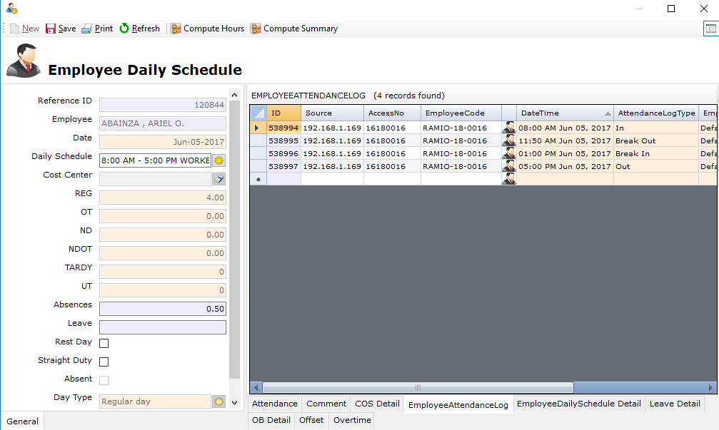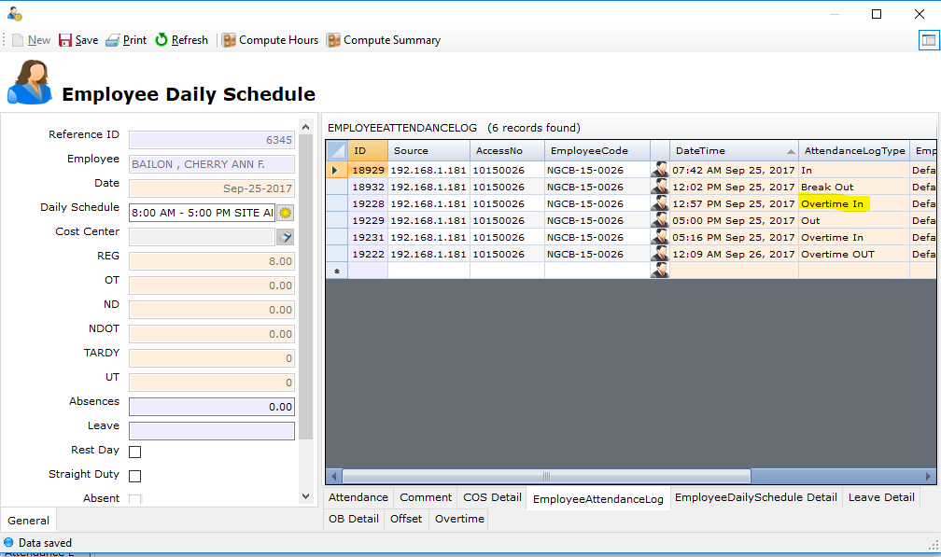

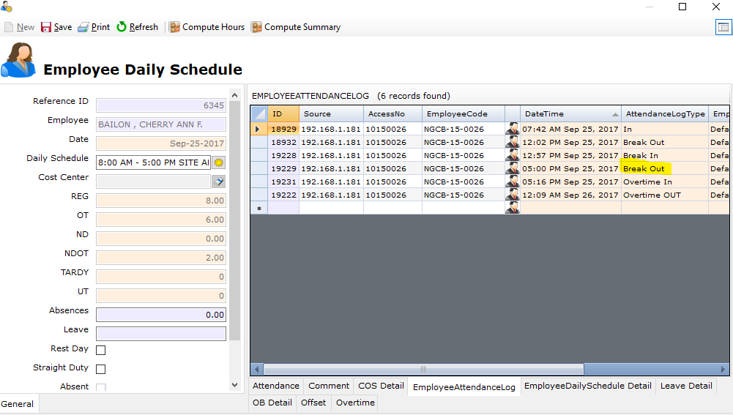

**1.1.27.1**

* Timekeeping – Overtime

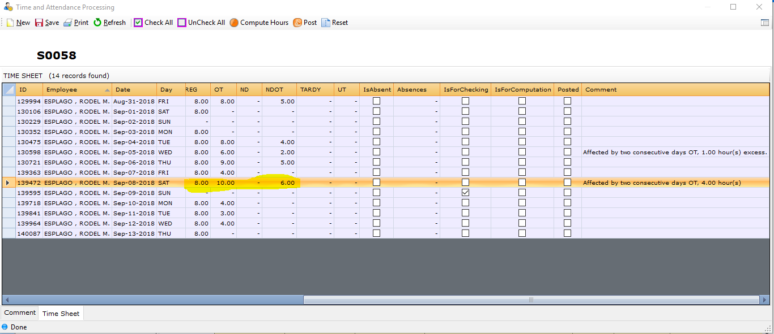

**1.1.28.1**

* Error on applying Employee Template File.

**1.1.29.1**

* Error message when approving zero leave credit item.

**1.1.30.1**

* OB with straight duty cannot be computed by the system.

**1.1.31.1**

* Change of schedule when straight duty is not automatically executed.

**1.1.32.1**

* Hanging when loading DTR report.

**1.1.34.1**

* Error when applying sick leave.
* Calendar logs arrangement.

**1.1.35.1**

* Wrong log type upon approval in missed log.

**1.1.36.1**

* Fix duplicate data in OT module.

**1.1.37.1**

* Updated Scripts from changer request

**1.1.38.1**

* **1.1.38.2**

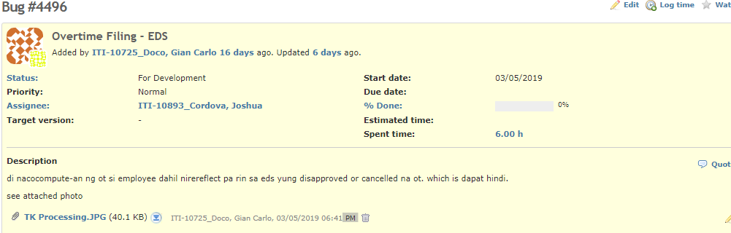

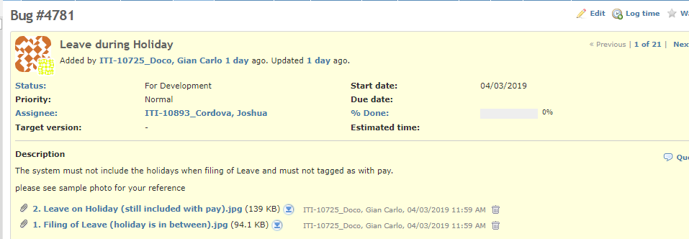**1.1.39.1**

**1.1.40.1**

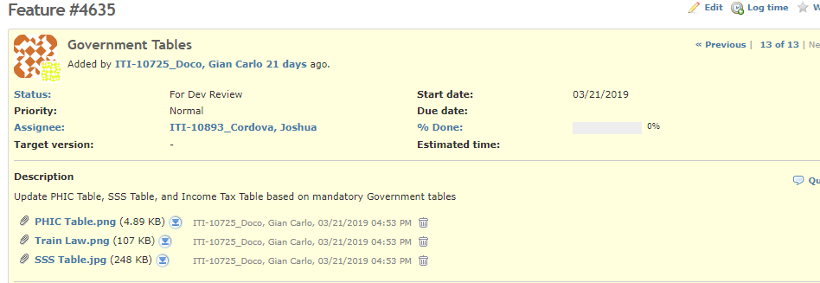

**1.1.41.1**

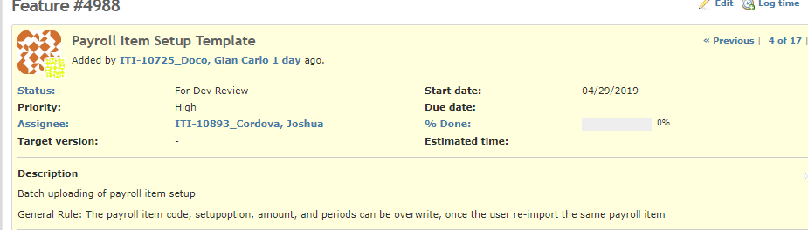

**1.1.42.1**

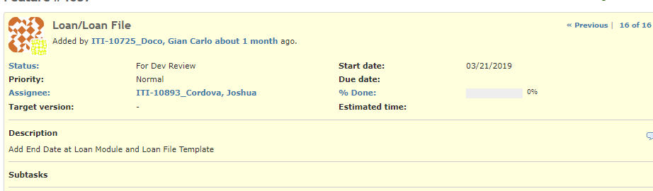

**1.1.43.1**

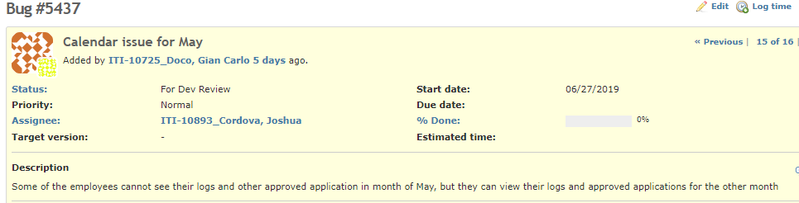

**1.1.44.1**

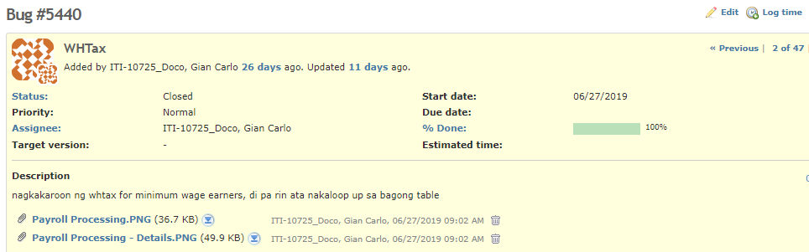

**1.1.45.1**

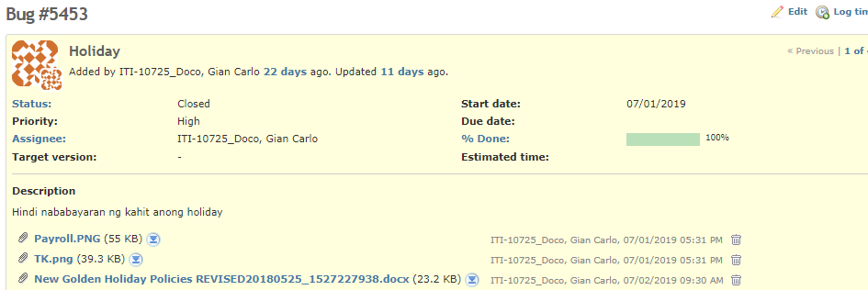

**1.1.46.1**

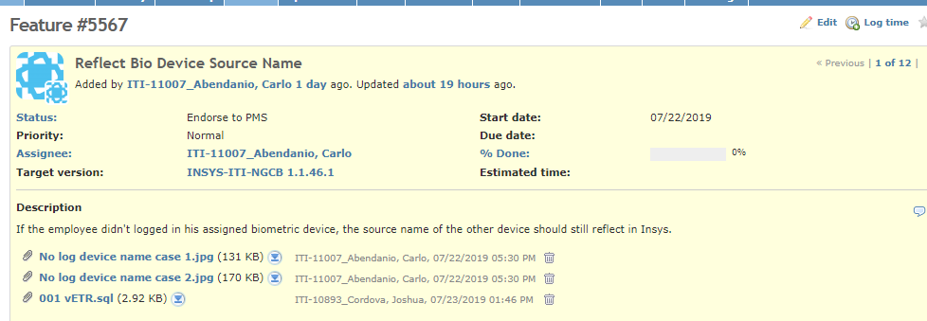

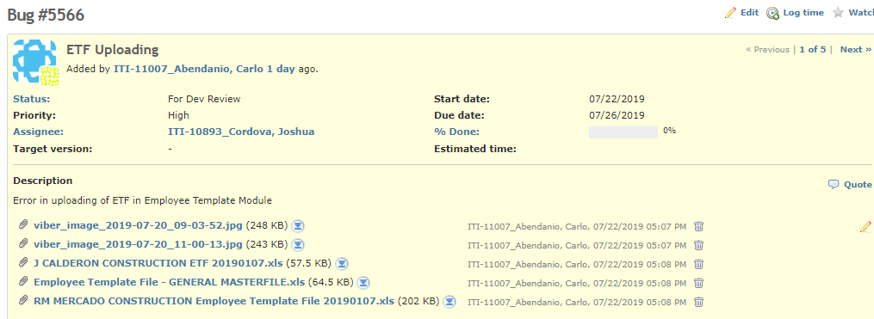

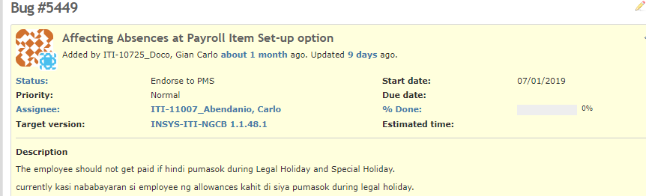

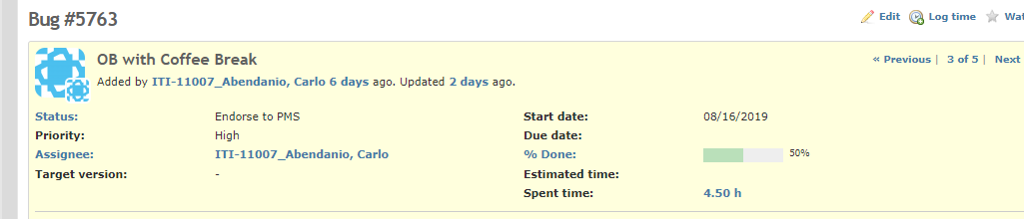

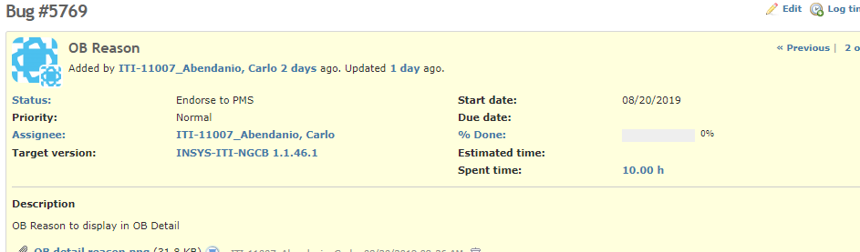

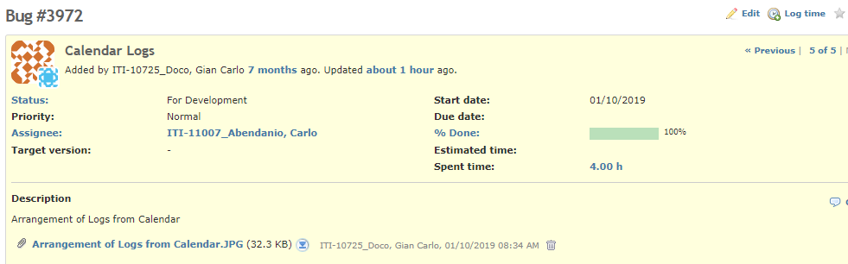

**1.1.47.1**

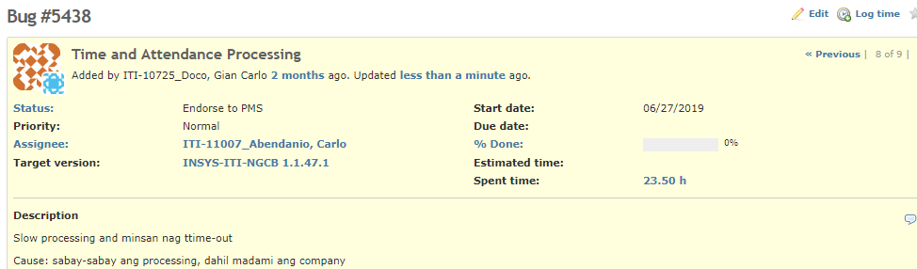

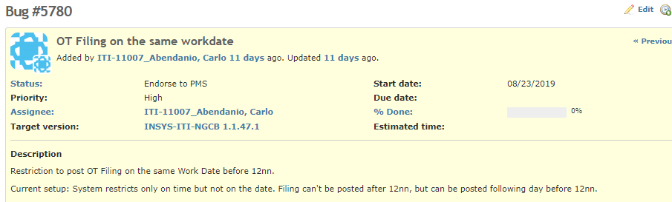

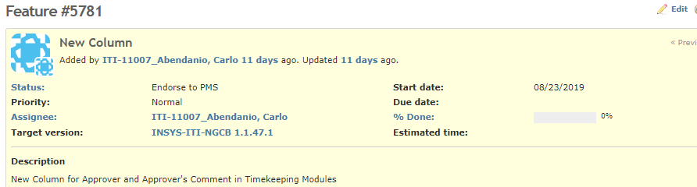

**1.1.48.1**

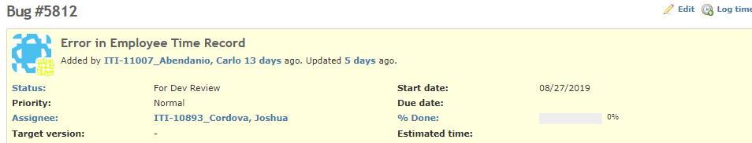

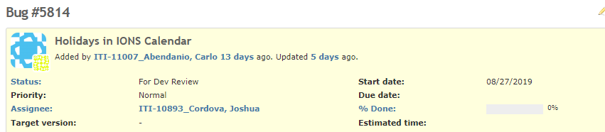

**1.1.49.1**

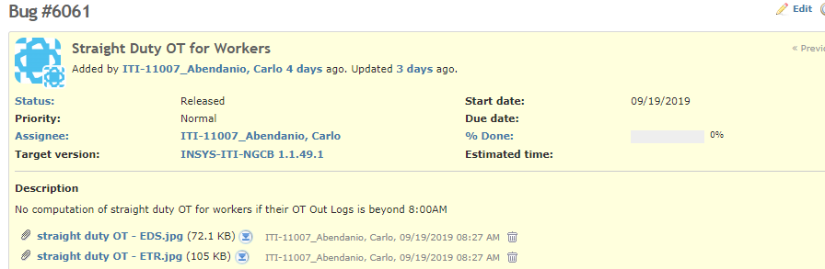

**1.1.50.1**

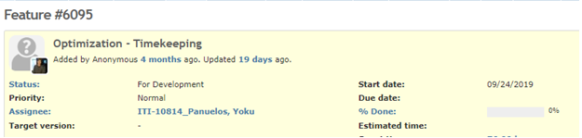

**1.1.51.1**

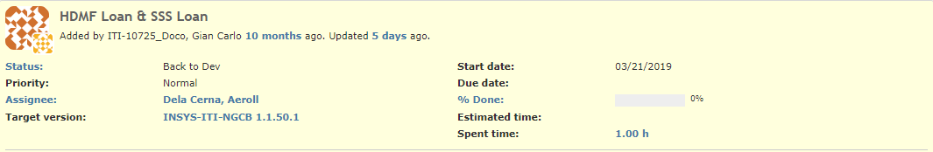

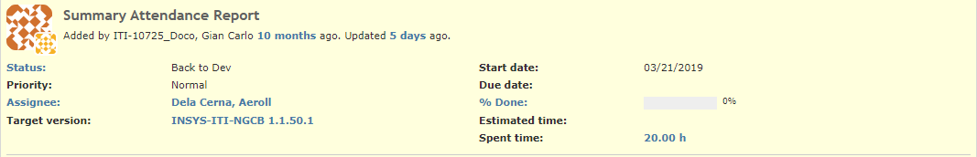

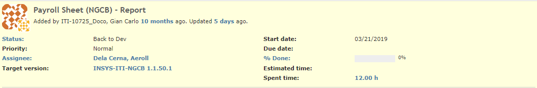

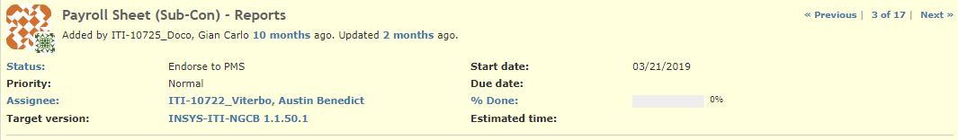

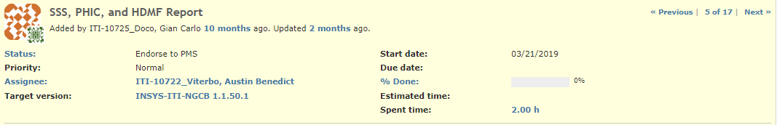

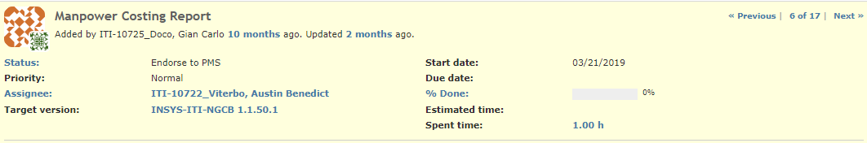

# **Known Issues**

**1.1.16.1**

* Previously inserted record from Employee Template File with NULL Division and Employee Classification must be updated to be able to compute employee’s timekeeping.

**1.1.23.1**

* Previously processed Timekeeping won’t update the comment for workers with two consecutive days overtime.

**1.1.26.1**

* Previously processed Timekeeping will not be updated.